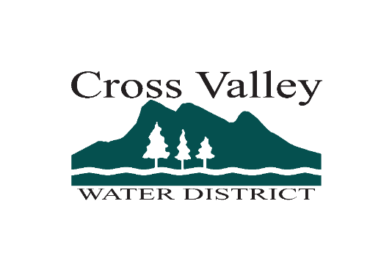

Utility Service Worker - Employment Opportunity – Cross Valley Water District

Open until filled
Join our team. Entry level to Experienced we have a place for you. Cross Valley Water District is seeking self-motivated individuals with preferred experience in water or sewer maintenance and installations. We are seeking committed, hardworking individuals with a passion to learn. Cross Valley offers all in one, PRV, Fire Hydrant, Meter maintenance programs, SCADA, new services, repairs, inspections, operate heavy machinery, just to name a few, all at your fingertips.
See the Full Job Descriptions at CROSS VALLEY EMPLOYMENT
Utility Service Worker I
Hourly Range for 2025: $37.13 – $47.38
Monthly Range for 2025: $6,434.89 - $8,212.73

Utility Service Worker II
Hourly Range for 2025: $41.30 - $52.71
Monthly Range for 2025: $7,158.86 - $9,136.72
Open until filled – accepting applications – First review 8/25/25
EXCELLENT BENEFITS
Available on the website – CROSS VALLEY
The District offers competitive pay, paid time off, paid holidays, and a wide range of paid benefits including, medical, dental, vision, life insurance, long-term disability insurance, a deferred compensation option with a 2% employer match, and more. This position is also eligible for the Washington State Public Employee Retirement System. This is a Local 302 Union represented position.
APPLICATION PROCESS
Individuals interested in applying for this position must submit a completed Cover Letter, Resume, and District Application.
Office Drop off or Mail: Cross Valley Water District, Application, 8802 180th Street SE, Snohomish, WA 98296.
Electronic application submissions available through the website. www.crossvalleywater.net
Incomplete application materials will not be accepted.
For questions, clarifications, or other information please contact Christine at (360) 668-1875.Cross Valley Water District is an Equal Opportunity Employer, Drug-free and Tobacco-free workplace.

